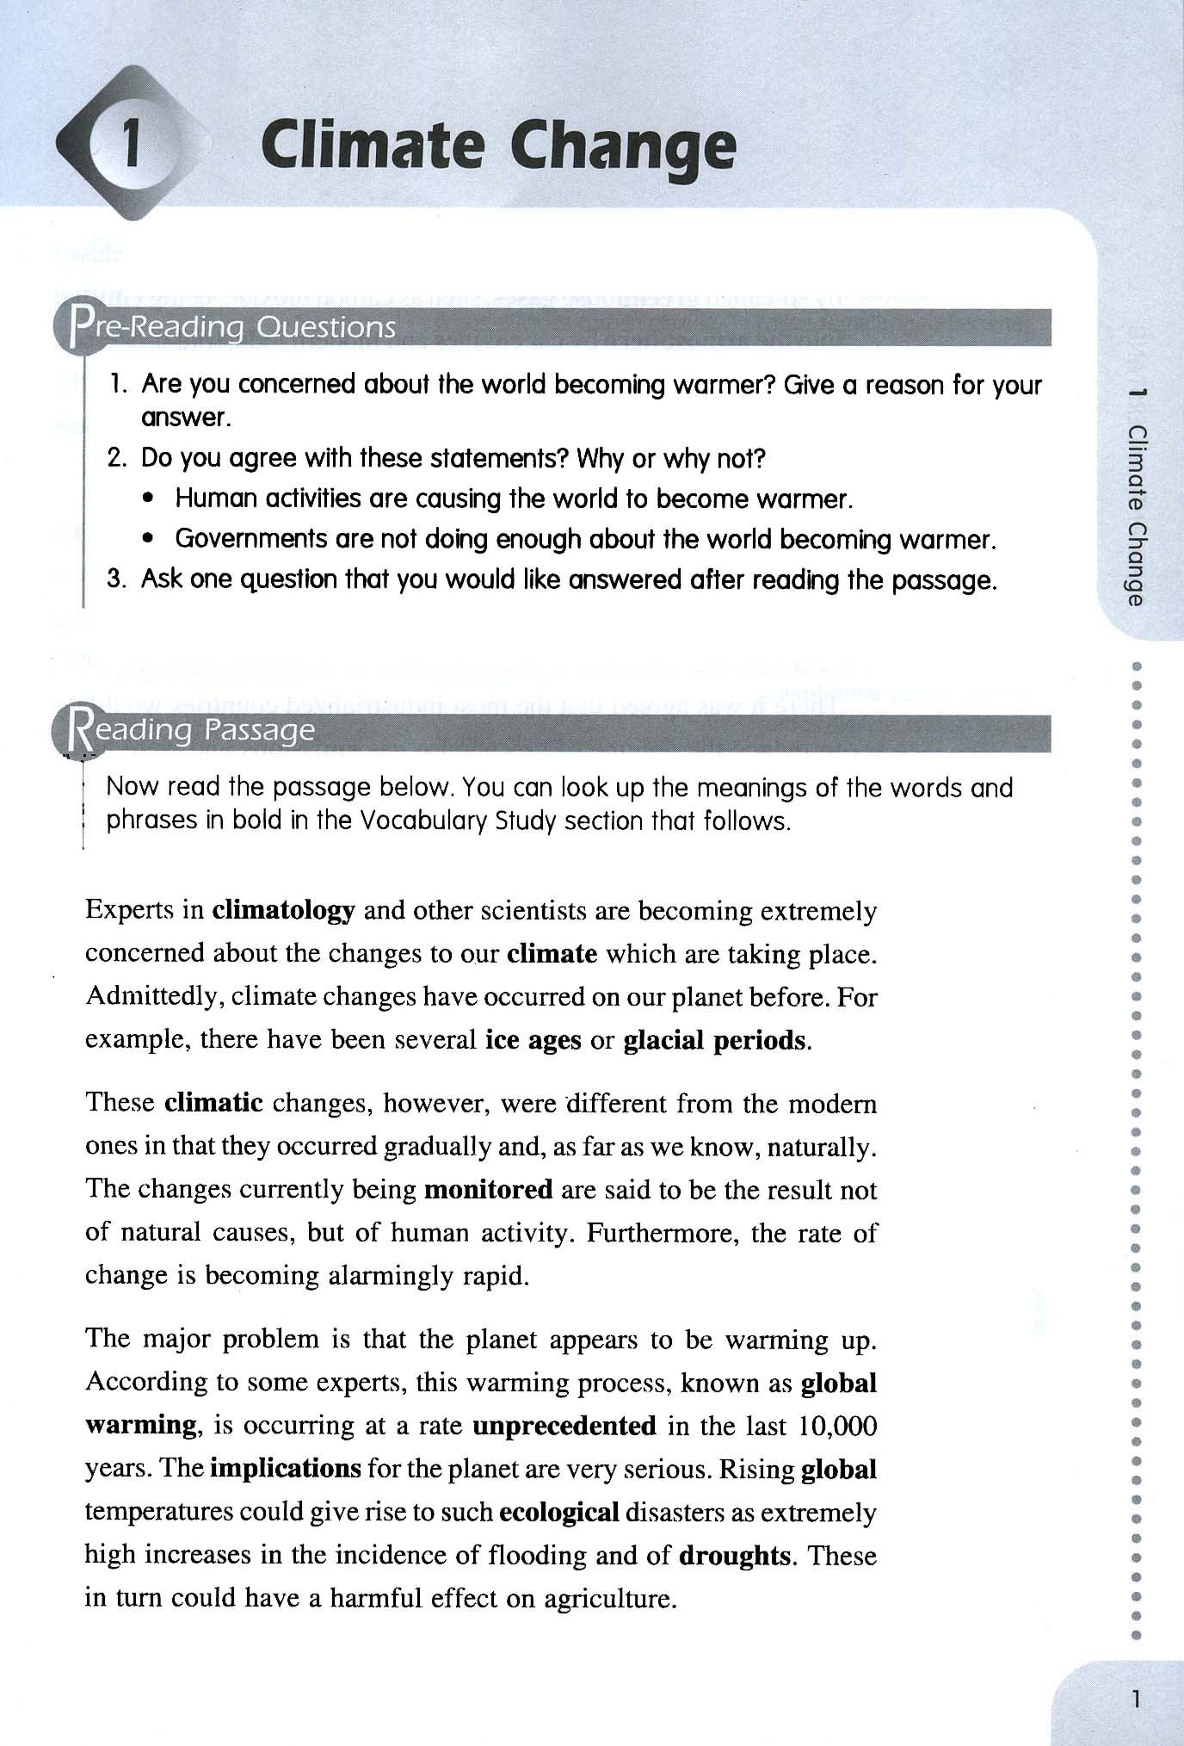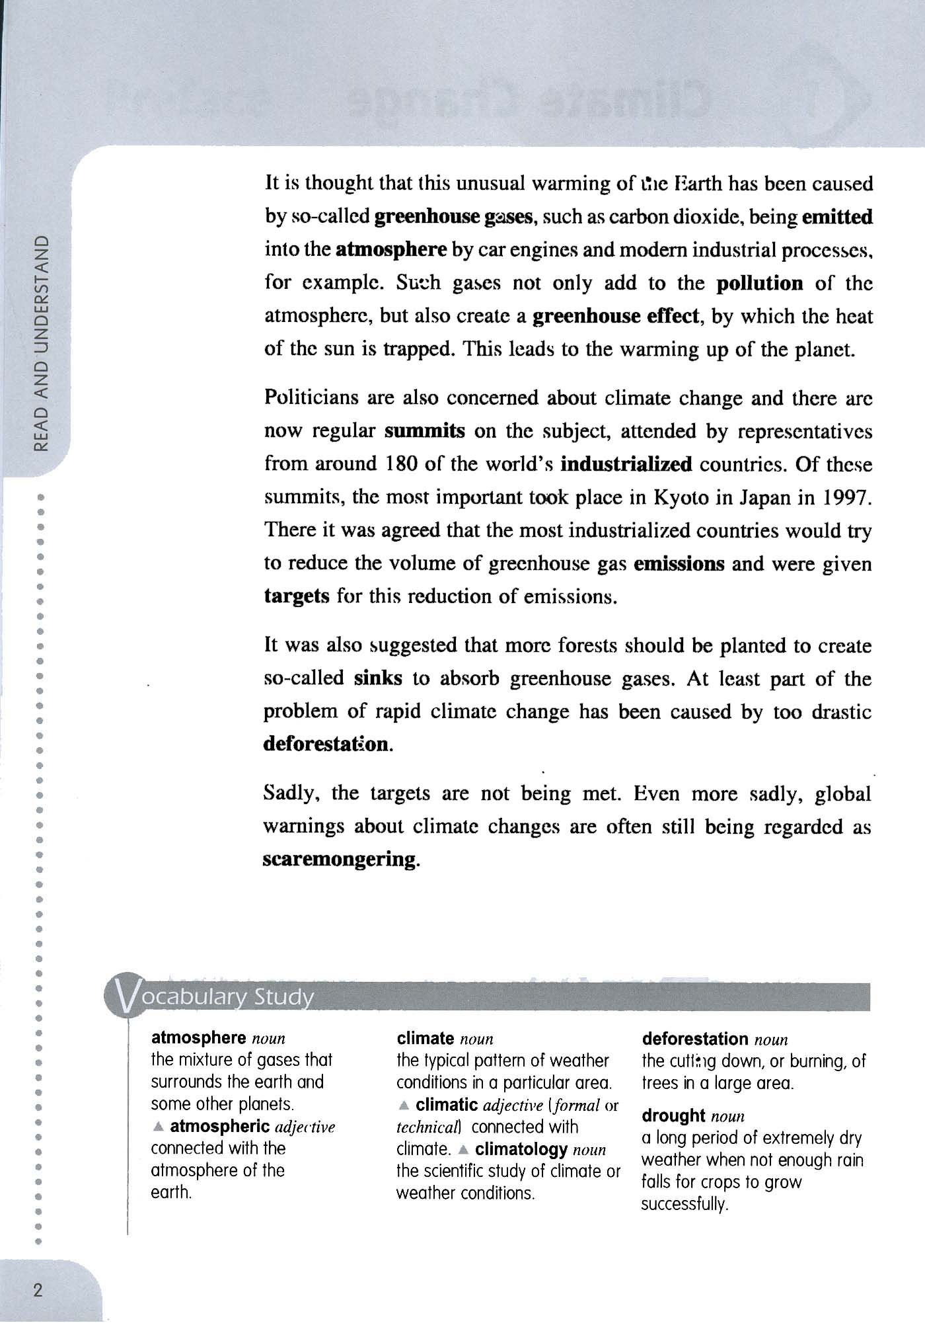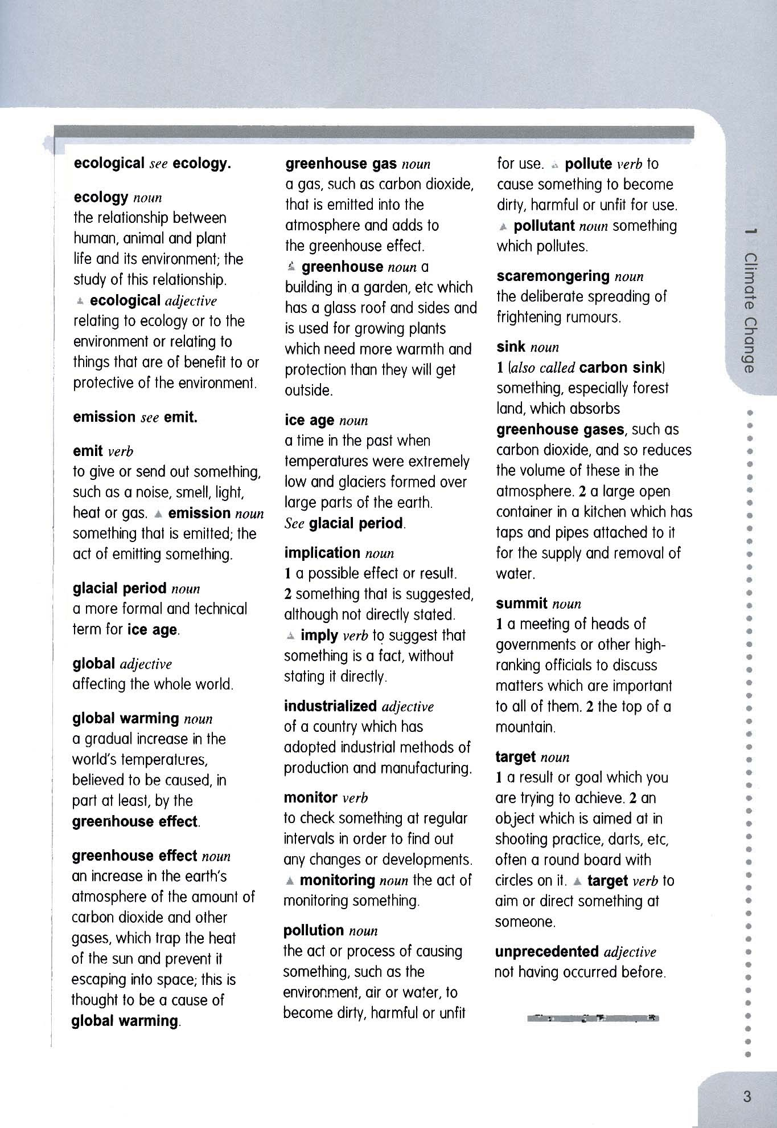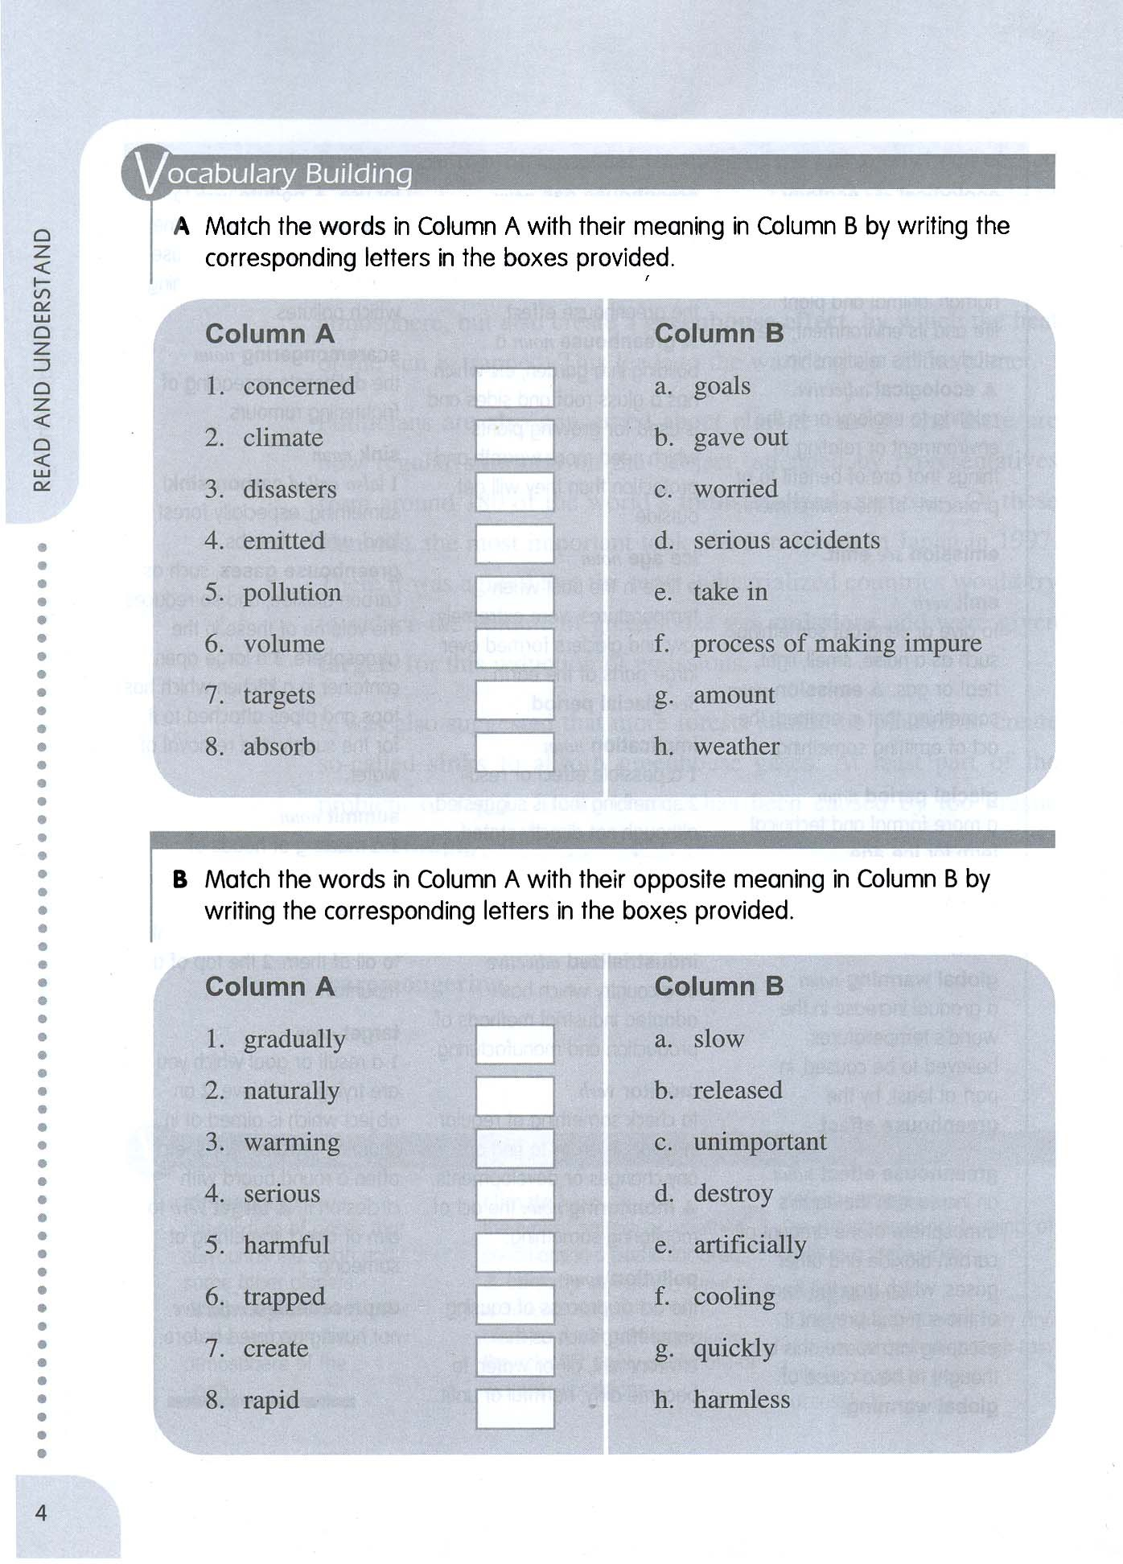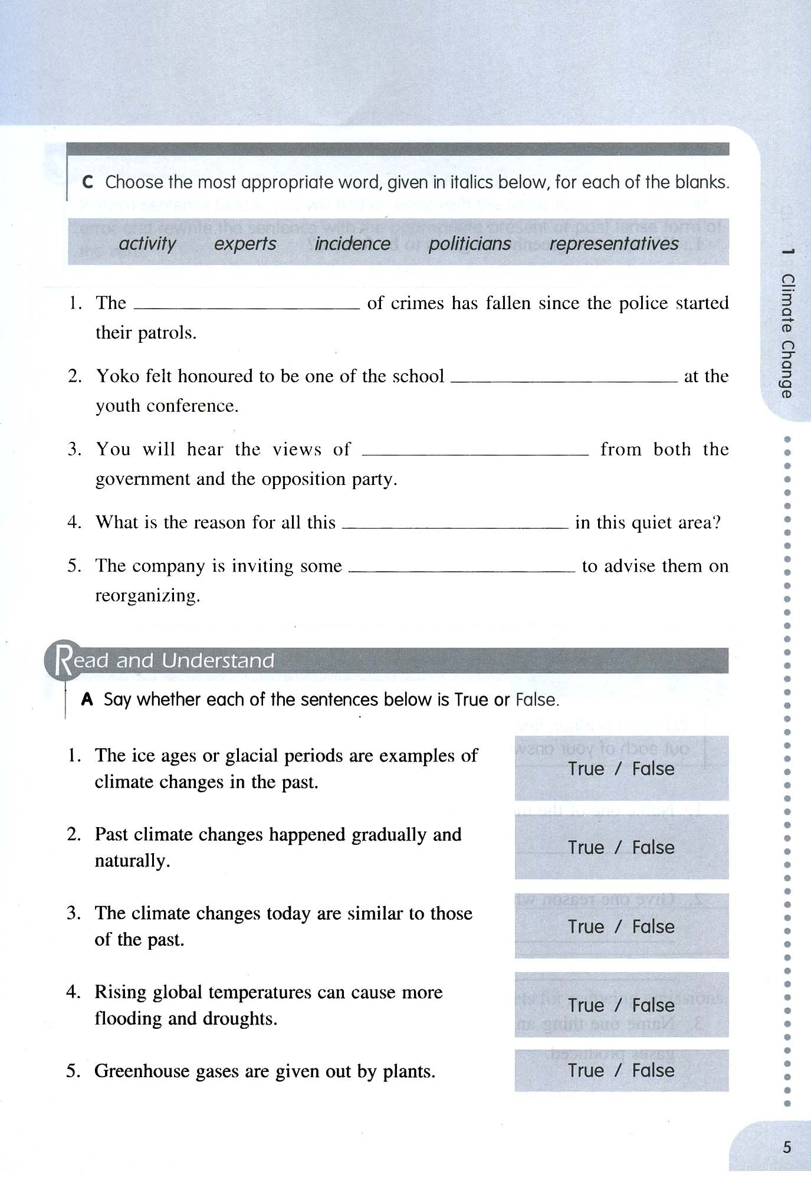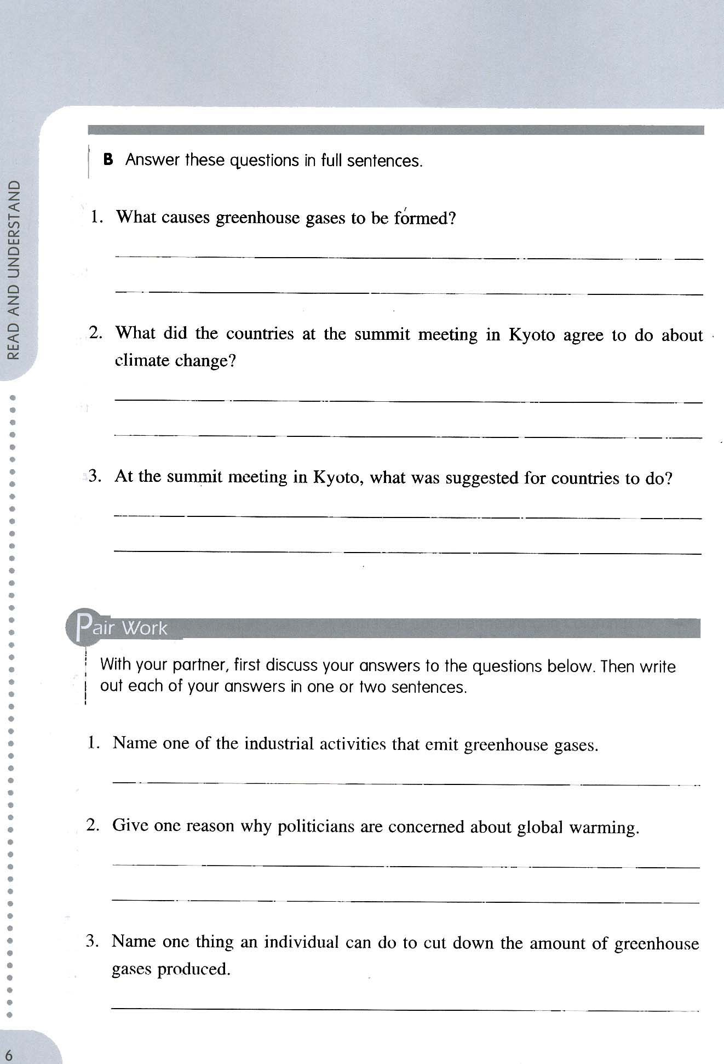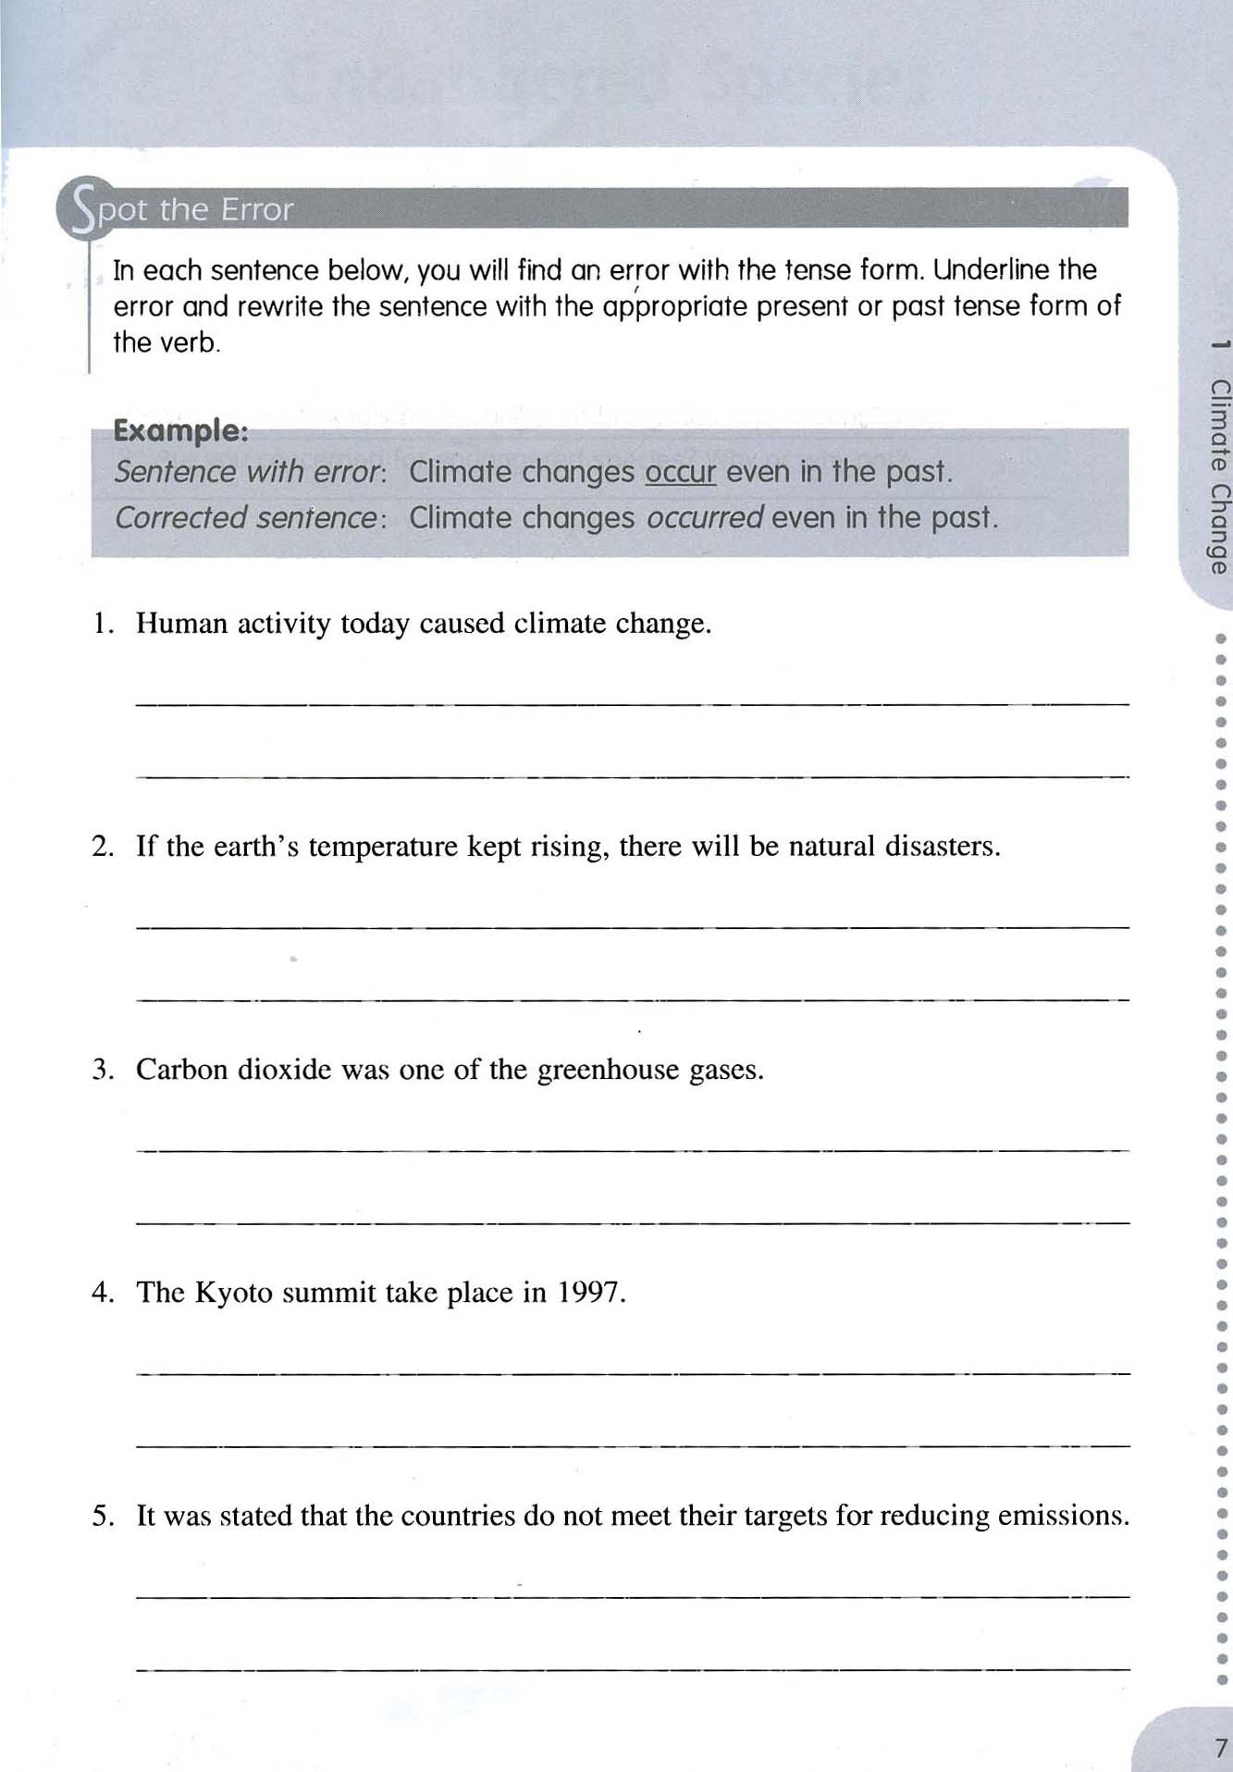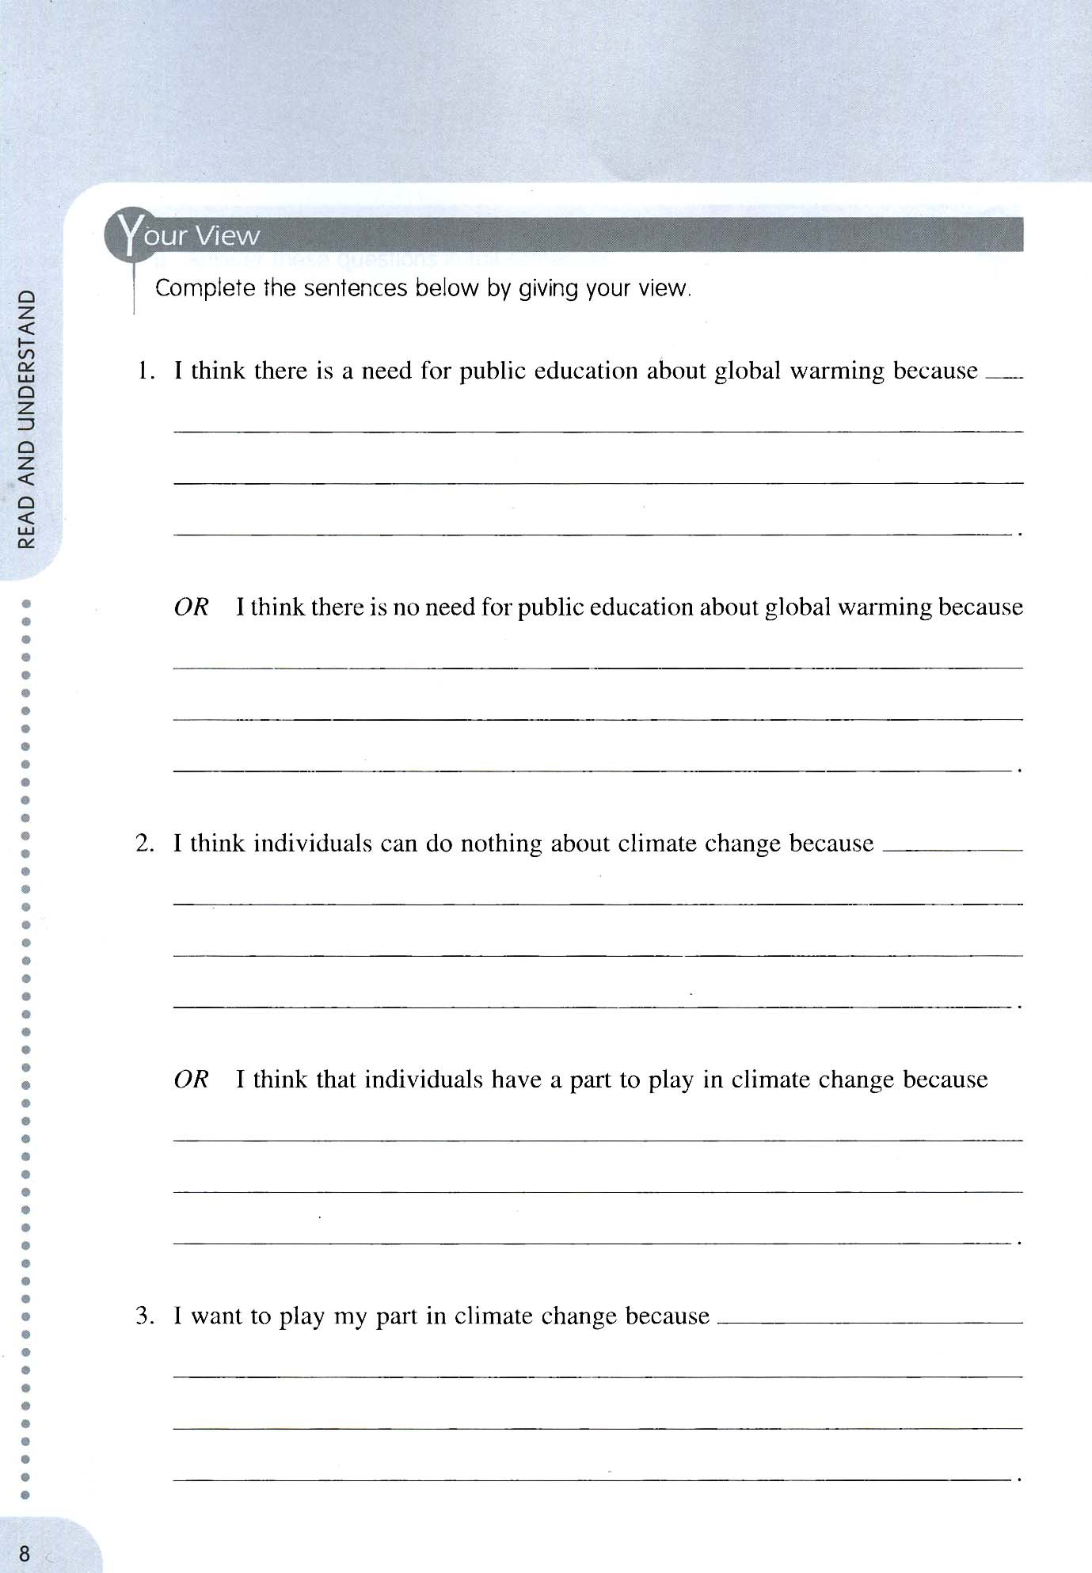

**Question**

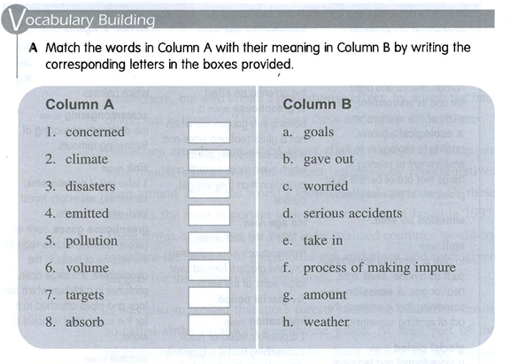

**Answer**

Column A 1 to c

Column A 2 to h

Column A 3 to d

Column A 4 to b

Column A 5 to f

Column A 6 to g

Column A 7 to a

Column A 8 to e

**QUESTION 2**

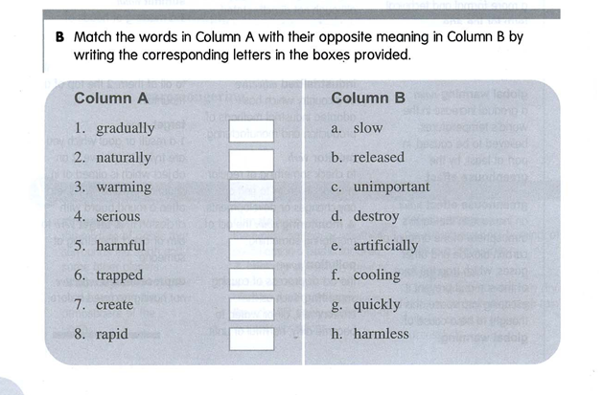

**ANSWER**

Column A 1 to g

Column A 2 to e

Column A 3 to f

Column A 4 to c

Column A 5 to h

Column A 6 to b

Column A 7 to d

Column A 8 to a

**QUESTION 3**

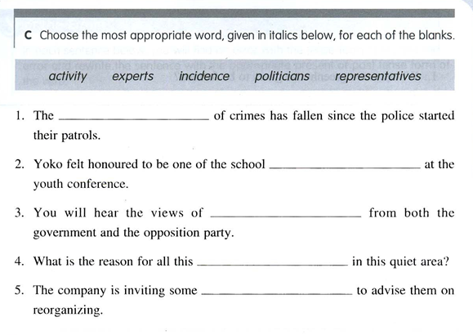

**ANSWER**

**1** incidence **2** representatives **3** politicians **4** activity **5** experts

**QUESTION 4**

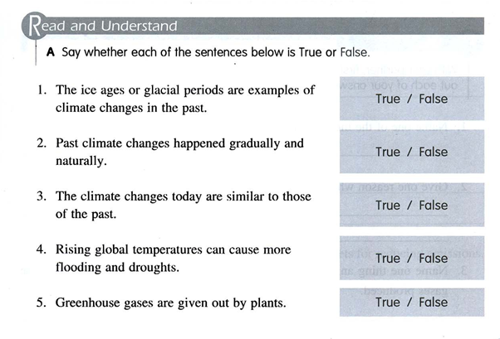

**ANSWER**

**1** True **2** True **3** False **4** True **5** False

**QUESTION 5**

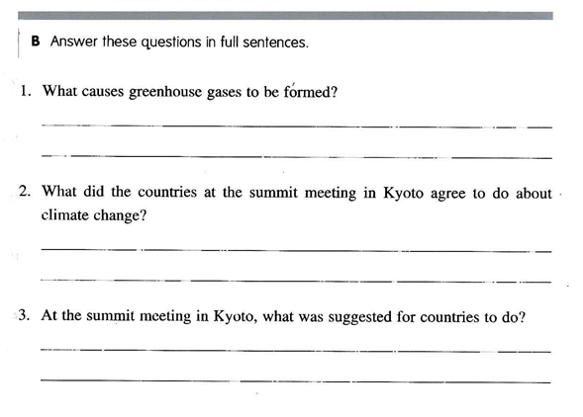

**ANSWER**

1. They are formed by car engines and industrial processes
2. They are agreed to try to reduce the volume of greenhouse gas emissions
3. It was suggested that countries should plant more forests to absorb greenhouse gases

**QUESTION 6**

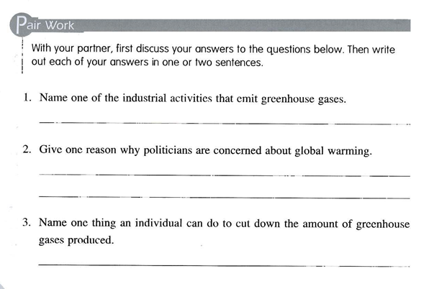

**ANSWER**

(1).  
There are many industrial processes due to which greenhouse gases emit but carbon dioxide from the car engines are the main source of greenhouse gases emission in to the atmosphere.

(2).   
Politicians are concerned about the global warming because the climate of earth is becoming warmer than ever and regular summits are held. Tasks are appointed to industrialized countries to reduce the greenhouse gases emission, but the targets are not satisfying. Need for the growing of forests is rising day by day.

(3).   
An individual can play a significant role to reduce this greenhouse gas effect by reducing the use of cars, bikes and by himself grows plants and promotes greenery. That is the best way for any individual to cut down the amount of greenhouse effect**.**

**Question 7**

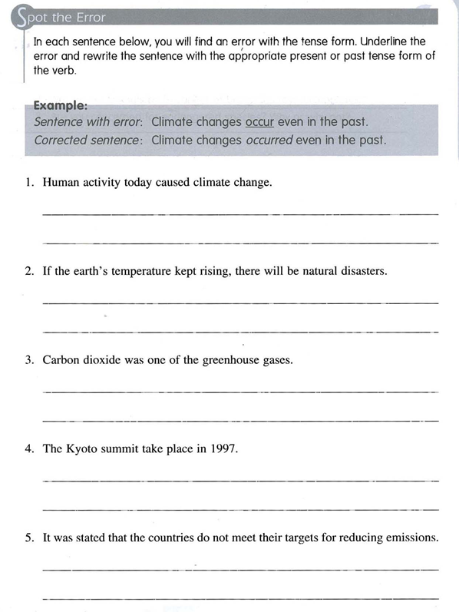

**Answer.**

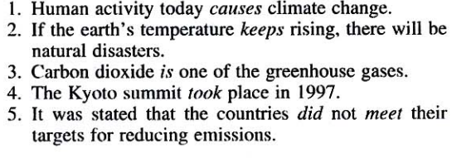

1.  
Human activity today causes climate change.

2.  
If the earth’s temperature keeps rising, there will be natural disasters

3.  
Carbon dioxide is one of the greenhouse gases.

4.  
 The Kyoto summit took place in 1997.

5.  
 It was stated that the countries did not meet their targets for reducing emissions.

**Question 8.**

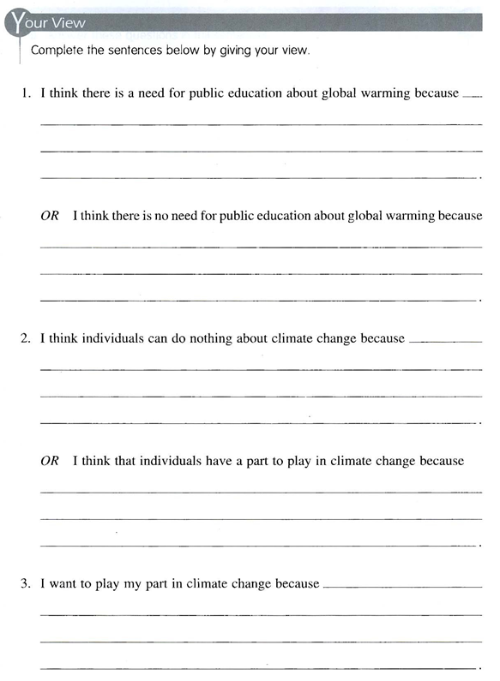

**(1).**I think that there is a need for public education about global warming because most of the people are not well educated and doesn’t know about the concept of global warming. So, literacy is the best way to spread knowledge about global warming and that can be very helpful for everybody.

**Or**

NO, I’m against this opinion that there is no need for public education about global warming. There is a strongly need of global warming education.

(2).  
No, everybody in this universe can play a role in reducing the amount of global warming. So, I disagree with this statement that individual cannot play a part in climate change.

Or

Yes, individuals have a part to play in climate change by reducing the use of motor bikes and cars that spreads pollution and spreads awareness among others regarding climate change. Promotes greenery and by own self grow plants and protects nature from harm.

(3).  
Yes, I want to play my part in climate change so that our atmosphere becomes clean and all hazardous gases in our environment reduces to no damage level for everybody. Promoting the benefits of plantation and protection of forests is my aim. I also wants that the use of cars bikes for small works must be stopped. Walking is the best way for small works and by doing that amount of carbon dioxide in the atmosphere gets low and by walking our physical fitness will surely be in good condition and we will remain healthy.